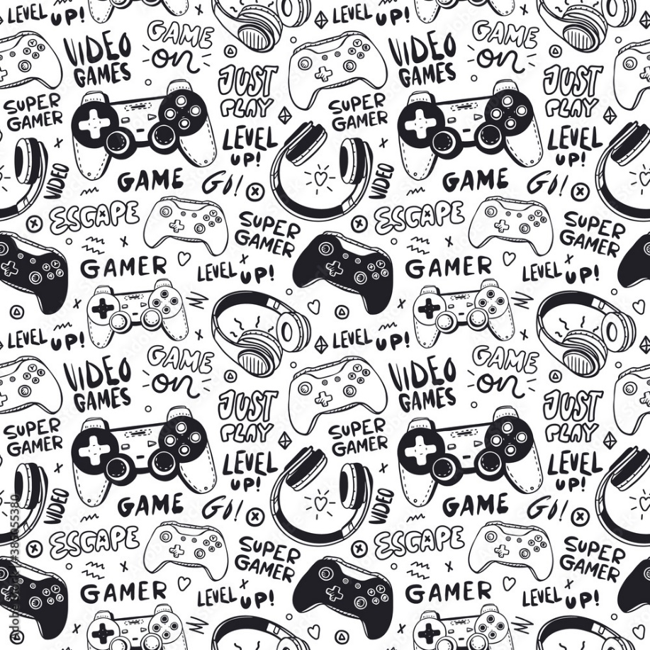

Minimum:

OS: Windows 10 64-bit processor

Processor: Intel Core i5-3470 or AMD FX-6300

Memory: 6 GB RAM

Graphics: NVIDIA GeForce GTX 750 Ti, 4GB or AMD

**Multimedia Game Studio**

EMAIL

hitoriMEstudio@gmail.com

WEBSITE

https://hitoriME.com/jp

PHONE

09393290115 / 123-456-789

SYSTEM REQUIREMENTS

NOPSIS

In its Digital Entertainment Business, hitoriME has provided distinctive game material and user experiences for more than 30 years, constantly changing to satisfy the video and console game consumer demands. We began by producing and selling amusement machines before branching out into the video game production and being among the first to produce and release mobile games. We have created ways to play that complement the unique qualities of each device as a result of the rapid growth of network-based entertainment and the advancement of gadgets like game consoles and cellphones. Additionally, we are actively promoting cross platform development, allowing our titles to be enjoyed seamlessly across a variety of devices.

ABOUT US

The game is set in the United Kingdom of Euchronia, a medieval fantasy realm mirroring the contemporary real world, after the assassination of its former King. Years earlier, an assassination attempt on the Prince resulted in him being cursed and falling into a long slumber. The protagonist, Will, an orphaned boy of the magic-wielding Elda tribe and the Prince's childhood friend, participates in the Royal Tournament, held to decide the throne's successor, journeying across Euchronia to rally support from its people while searching for a way to lift the curse.

SYNOPSIS

OUR LATEST GAMES!

z

**Christian Postrado Regalado**

**Game Studio Director**

**HitoriME Studio offered unique game content and user experience in its Digital Entertainment Business, continually adapting to meet evolving costumer needs.**

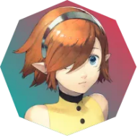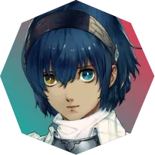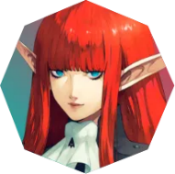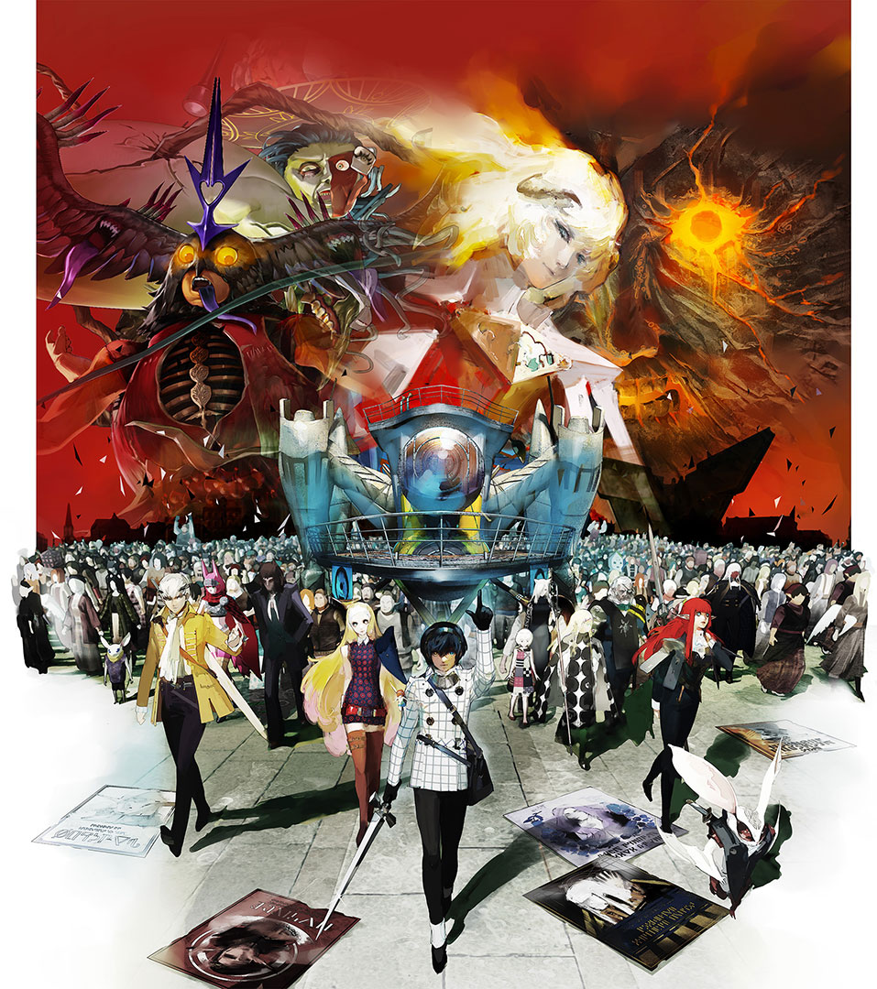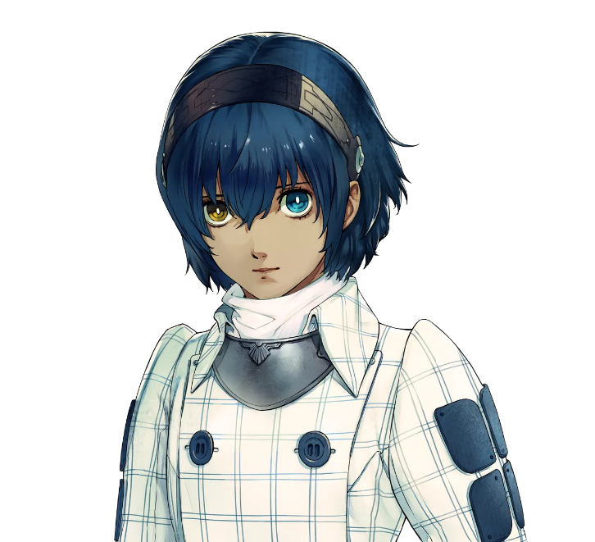

**Disclaimer: I do not own any assets; this is just for project purposes only.**

**CHARACTERS**